SQL Assignment-3

**1: Write a SQL query to find Employees who have the biggest salary in their Department.**

**Query1:**

SELECT * FROM emp WHERE(salary,dept_id) IN (SELECT max(salary), dept_id FROM emp GROUP BY dept_id);

**Output:**

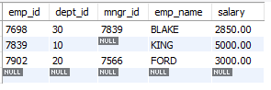

**2: write a SQL query to find Departments that have less than 3 people in it.**

**Query2:**

SELECT * FROM department WHERE dept_id IN (SELECT dept_id FROM emp GROUP BY dept_id having count(dept_id)>3) ORDER BY dept_id;

**Output:**

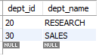

**3: Write a SQL query to find All departments along with the number of people there.**

**Query3:**

SELECT d.*,count(e.dept_id) working_emp FROM department d INNER JOIN emp e ON d.dept_id = e.dept_id GROUP BY e.dept_id ORDER BY dept_id;

**Output:**

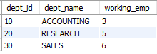

**4: Write a SQL query to find All departments along with the total salary there.**

**Query4:**

SELECT d.*,sum(e.salary) working_emp FROM department d INNER JOIN emp e ON d.dept_id = e.dept_id GROUP BY e.dept_id ORDER BY dept_id;

**Output:**

